System Title

SRS

Introduced By Author or Company Name

|  |  |  |  |  |
| --- | --- | --- | --- | --- |
| Version | Written By | Reviewed By | Approved By | Date |
| 0.X |  |  |  |  |
| 1.X |  |  |  |  |

# Table Of Contents

## 1. Introduction

1.1. Executive summary

1.2. Document Overview

1.3. Abbreviation and Terminologies

1.4. References

## 2. System Description

2.1. Introduction

2.2. Users

2.3. Modules

## 3. System Users

3.1. User Description

## 4. System modules

4.1. Module description

## 5. System Functions

5.1. Module functions

## 6. System Models

6.1. Case Diagrams

6.2. Sequence Diagrams

7. Non-Functional Requirements

7.1. security

7.2. Usability

7.3. Performance

7.4. Technology

7.5. Development

7.6. Delivery

7.7. Operation

## 8. Domain Requirements

## 9. System interfaces

9.1. User Interfaces

9.2. Communication Interfaces

9.3. Hardware Interfaces

# 1. Introduction

## 1.1. Executive Summary

This software system will be a Web Software which will offer a punch of great a lot of things, so lets now be more specified and knows more details on our project

Simply our project is an electronic website in which you can find and read everything and latest news in electronic devices, also the user is allowed to Sign up on our website to receive notifications about the latest news and updates, also if he wants to make a favorite list, he can do that and save it on his email in our website, also the user can compare between two different devices so if he wants to knows which of them is better than the other to buy it or just for knowledge we will make him able to do so, our website should provide something like tips to help the user using different devices, and if he wants to know some information about that device on our website.

## 1.2. Document Overview

The next section of this document will talk about System description and goes in details about the user interface and the system and modules, after that we will held each point in the system description and talk briefly on it to understand it well, And we will start with System users in which we will talk about user description in detail and understand everything in it, then we will talk about our second point which is System modules which we will held Module description in it and talk briefly about it.

The third section we will talk about is system functions which have punch of points inside it

Then we will talk about System models and talk about two different things:

1- case diagram 2- sequence diagram

Then we will move on to the Non-functional Requirements in which we have a lot of things inside it which we will discuss in detail, it contains all the requirements needed in our system illustrated Like:

1- Security 2- usability 3- Performance …etc

For sure we all knows the importance of those requirements and how we need those things being applied on our website to make it more flexible

Another section we will discuss in that document Is the Domain requirements which is very important for any developer to understand what is needed in that website

Then the last section we will discuss is System interface which includes different interfaces like:

1- Communication interfaces 2- Hardware interfaces if required And any other interface required in the project

# System Description

## Introduction

As mentioned above that our system is something that allows you to do multiple things and now, we will make a quick introduction through it, imagine a system where all you want to know about electronics is here. first the user needs to sign up an account to receive notifications about the latest news in electronics world and electronic devices. the system offers to build the electronic device user wants to buy based on choosing the specifications he is interested about like: type, price, color…etc.

### Login

first of all, when the user opens the website, he will see two options either to login his profile or to sign up for a new account. The system allows this function in order to:

a-send to the user the latest electronic news and devices that he wants to hear about and searches about them the most.

b-makes it easier for the user to find all what he is looking for in one place

### Choose items

When the user enters his profile:

a- the system will recommend him a variety of electronic devices like mobiles and laptops with different models, prices, sizes, colors and techniques.

b-All the user must do is to select what he likes the most and wants to hear and know more about.

c- After that the system will send to the account of user all the news about these devices and their new updates and new specifications automatically.

### Build your device

when the user decides to buy a new device:

a- he should select which type of devices it is (computer, laptop, mobile), then a list of specification sections will appear like (color, price, size, ram , processor , graphic card , cache memory , internal memory ).

b- in each section the user can choose whatever he wants, and after filtration the system offers all devices which have these specifications, so the user can go through them easily and readily.

### Compare between devices

when user is confused between two or more devices that he likes or wants to buy. the system offers the user a page which lists the specifications of each device separately from the other, so the user can see clearly the specifications of each device and can decide easily which device is more suitable and appropriate for him.

(HINT: this function doesn’t say which device is better in each specification, it just displays the specifications of each device).

### Recommendations for buying

when the user settles on a certain device, here comes the final step as:

a- the system offers the user many online links where he can buy this device from directly.

b- In each link the user will find the device with its specification, cost and shipping expenses

c-if there is any discount, this will be declared in the online links.

## Daily Tips

Most websites offer daily tips to customers:

a) to enrich their information

b) to provide them with knowledge they need in certain domain.

Not all people are aware of technology and technological devices, so they need more information about what they have in hand:

a) to make their life easier

b) to be more in touch with those devices.

Tips are very simple statements, written in simple language for all people with different ages so everyone can benefit from them. You don’t have to be expert to understand tips as tips are written for people who don’t belong to this domain. There is a tip for everyday and something new to learn about. (for example, how to have good habits for prolonging the cellphone’s battery life.)

### Email notifications

Email notifications are helpful because they provide the user with information in quick way without the need to check the website every now and then. Whenever there is something new or information updated on the website that the user needs to know, email is sent to the user’s inbox to notify him about whatever he needs to know that is now available on the website. Email notifications can vary:

a) they could be about product the user has previously added to his favorite

list

b) they could be about a new product that is released onto the market

c) they could be a new piece of information he wants to know about. Email notifications are frequent to ensure that the user is well connected with the website in the most efficient way, all what the user needs to do is signing up on the website.

### Favorite list

Most users like saving certain products that they are interested in, to know about them more in another time, so favorite list does that job. Whenever the user likes a product, but he is still undecided whether to buy it or not, he can add that item to his favorite list to check it later without the need to search for it again. The user may like to add multiple items to his favorite list to probably compare between them when he wants. Favorite list will include all items the user wants to save for later use, or items the user is interested to buy. Favorite list is efficient way to keep the devices the user is interested in, in a safe place. There is a favorite list for every user when he signs up on the website, so it’s too personal and private.

### Adding new products to the website’s database

Every now and then, a new technological device is released onto the market with improved qualities than before, and spare parts are becoming available, since technology is changing very fast in our era. In the past, there was a big gap between one and another technology. Technology was not evolving in a quick way, there were many things yet to be discovered and implemented . But now, we are in the 21 centuries, having a lot of talented and skillful engineers working hard every day to discover more and more and challenge themselves to go beyond what have been known as the latest technology. So, a website regarding technological devices need to be up-to-date whenever a device is released, or any information could be updated. So, having an option as a website owner to have the ability to add new device without much coding and without much knowledge about programming is a great functionality indeed. Whenever you need to update your website and add more information, you can do it easily and in quick simple steps.

### Technological information

A lot of technological definitions are not well known to most users. There are a lot of definitions that need experts to understand them well. Technological definitions can be scientific or commercial, so it’s complicated to be familiar with these definitions without help from those who know more than you. As in our modern era, a lot of people are showing interest in technology and read a lot of sources to be cultured and have better awareness of how the world evolve rapidly. Technological devices are common with teachers, drivers, students, doctors. etc. All these people need more brief information and definitions about the technological devices they own. They also need to know such pieces of information when they need to buy a new device with quality that suits them the most. So being provided with technological information is the best help they can be offered to:

a) understand their needs

b) Know what to look for in the device they want to buy Also if anyone is just interested in technological books and courses, he can know about the best courses and books available for him to start self-learning.

## Users

The user can compare between devices, add his favorite devices to cart and when the user settles on certain device, the system lists online websites where he can buy it from. The system offers daily electronic tips to the user like: how to extend the lifetime of a certain device, save the battery, instructions during charging and many other tips. if the user wants to know about electronic information, he has no idea about it, all he needs to do is to search about this information in the section of technology information where he will find the description of it like: graphic card, ram, rom and some examples on it.

# System Users

## Find your electronic devise

User can easily find the system he is looking for by specifying what he / she interested to do on this device or why he need it. for example, if user need mobile for gaming or taking professional photos, he will have the devices which doing that perfectly. Also, the user will have some filter to make the search on devices easily and allowed the user to find the most adequate device.

## Getting tech information

User can understand every parameter and tech on the device he interested to buy, and what is the best for any parameter, for example he can understand why a certain CPU is efficient or more powerful than another CPU and what is the meaning of a certain tech like multicore Show your shop

Electronic stores can make a page on the site and add the item they are buying on it and the price of every item and some details about them. and the user will find that this shop is buying that device on the page of the device.

## The authenticity of the info

User can trust in every information and details of any device on the site as it will be taken from the company made that device.

## What's new

User will know any news about electronics. the news will contain the new devices on the market, the new techs, the news of the electronics companies like (Apple, Samsung, Intel) and the user can receive message on his email to keep in touch in this news.

## Simple interaction with user

User can browse the site easily, he can register on site and that will manage him add any subject on the site to his profile favorite list and back to it later from his profile, he also can choose topics he is interested in to get its information as soon as it will be available on the site, user will also enjoy receiving notifications on his profile and on his email about any new information or subject on his interested fields to keep in touch with its favorite topics.

## Follow your favorite brand

user can choose brands or the company he is interested in to get any new information or news or new products about his favorite brand.

## Good classifications

The site will show to user an organized data and topics. The site will have separated sections to ensure an organized data and not interfere the subjects from different fields on electronics. For example, section for devises, news, electronic information and there are sub sections in the main sections to ensure organized data.

## User interface

our site will include many sections on it and each section will have many pages on it

• mobile section, news section, computer section, information system for example mobile section will have more than one page.

• page to explore the mobiles and the new mobiles in the market.

• page for each mobile to show its properties.

• A page to Compare between two mobiles or more.

• page to let user to find a mobile based on filters. so, there are many pages, data and details on the site. our site provides to its user the flexibility, many web sites have multicable pages and many details which make many users confused unlike our site. there is a fixed part on the screen that will let user to:

• go to any page from the main pages on the site (section page)

• enter his profile

• show his notifications

• open his favorite list

One more thing there are many web sites provide Services we already provide but this web site will be made to improve offering this service. for example, comparing device with another device, user can just Compare between two device or more on other sites, our site will show him devices similar to the two devices he is comparing, he may be listen nothing about them, user also will be provided a links that may help him to know about his device.

these links will be:

• review for the device

• videos and articles for the device

user also will find simplicity while using the site as the site is fast and has a

simple design makes any user use it simply.

## Pc picker

our website provides the service of get your computer to two types of user. The simple user can find his computer without deep knowledge on computer systems and without knowing every piece on the computer and what does it do and what is the difference between it and other piece. simple user should only determine two things:

• his budget.

• why does he need the computer or the main use on the computer?

And our website has systems of computers which were defined for every use and for budgets. And the other type of user who has knowledge about the computer and would like to determine some pieces on the computer like:

• CPU

• Memory

• Hard disk

• Graphic card

# System Modules

Our system consists of the following modules:

1. Build Your Computer

2. Comparison

3. User Advantages

4. Shop Owner Advantages

5. Recommendation

6. Increase Your knowledge

7. Profile

We will discuss every module and show you how they do.

## • Build Your Computer

This module is one of the best modules we have here in Electronic News Website. this module allows the user to build the computer you want with all the specifications that the user want. This module makes the user be very happy when he uses it because he doesn’t need now to see all the products to find the most suitable product for him. Now we saved his effort by letting him build his computer and find it very fast. The user now does the following steps to build him computer:

• Select the type of the product

• Select the type of processor

• Select the type of the graphic card

• Select the size and type of ram

So, when the user finishes these steps now, he can see the results of his specifications and this the best thing that we saved his time by making the choices less than the normal way. So when the results appear to him, it will be showed in the best way to make and agree with his specifications to make him choose the product he wants by the most easiest way.

## • Comparison

After we searched for the best choices of the products, we still have this doubt with the products we choose. So, what we can do for this problem? We take this problem into consideration when we thought about this website and the solution of this problem is here in this module. This module provides a good comparison to the user to select the best product he wants. our comparison module compares with a lot of specifications to make the user see the difference between the devices very clear and doing this by the most common and effective parameters in each product. this comparison based on the features and the type of each product.

## • Recommendations

If you are a person who wants to know everything new in the world of electronic devices or fan of products of a certain company this module will make you happy. Recommendations module allows the user to see the most recent updates about his favorite products or companies by letting him choose the products or the companies he wants to know everything about it. We provide the suggested products from the choices that the user chooses to make him see the latest news of every product he wants to hear about.

## • User profile & favorite Module

In this module we make the user special accounts. these accounts allow the user to benefit from the different features that the website provides. These features allows the user to compare, see recommendations and build his computer etc .. In this module we provide profile to each user to make it easy for him to save the products he chooses. This thing we called it favorite module to make the user save every product he wants in this section.

## • Shop Owner Module

The users of the websites differ from one to another so when we take this thing into consideration. there are users wants to buy products also there are another kind of users called the shop owners. These kind of users wants to show the customers its products by letting every user see it online, so we made this option to them. Every shop owner will have a different account. this account letting him show his products putting his price but to publish it in our website he must fill the standard specifications and describe everything he wants in this product to make the customer have a good idea about the product. Now the customer can see the products with its description to choose the best suitable product for him. this module makes the website suitable for a lot of kinds of users. this thing makes a great benefit to a huge sector of users.

# System Functions

## Shop Owner Functions

### Add product Function

**Description**: This function make the shop owner add his products to the website.

**Inputs**: name of product, its type, salary .

**Outputs**: publish product to website .

**Pre-conditions**: shop owner must be logged in .

**Post-conditions**: description function must be created .

### Edit Product Function

**Description**: Edit the product provided .

**Inputs**: The product you want to edit .

**Outputs**: Publish product after editing .

**Pre-conditions**: The product must be created first & shop owner must be logged in .

**Post-conditions**: none .

### Delete Product Function

**Description**: Delete product of yours.

**Inputs**: The product you want to edit .

**Outputs**: return to the Home page .

**Pre-conditions**: The product must be created first & shop owner must be logged in .

**Post-conditions**: none .

## customer Functions

### Get My Favorite Function

**Description**: Add product to Favorite list.

**Inputs**: Favorite product.

**Outputs**: product tagged as Favorite .

**Pre-conditions**: The product must be created first & customer must be logged in.

**Post-conditions**: none

### Edit Favorite Function

**Description**: Edit favorite list.

**Inputs**: Favorite list.

**Outputs**: list after edition .

**Pre-conditions**: The list must be created first & customer must be logged in.

**Post-conditions**: none

### Delete Favorite Function

**Description**: Delete Product from favorite list.

**Inputs**: Favorite product.

**Outputs**: favorite list without that product .

**Pre-conditions**: The product must be tagged as favorite & customer must be logged in.

**Post-conditions**: none

## User (Profile Module) Functions

### Get info Function

**Description**: Create account to the user .

**Inputs**: email , password , username.

**Outputs**: account on website .

**Pre-conditions**: user must enter his personal info to create an account.

**Post-conditions**: none

### Edit info Function

**Description**: Edit account information .

**Inputs**: User Account .

**Outputs**: account after edition .

**Pre-conditions**: User must be logged in .

**Post-conditions**: none

## Product (Build Your Computer Module) Functions

### Get CPU Function

**Description**: Getting CPU for product .

**Inputs**: Select CPU.

**Outputs**: CPU selected .

**Pre-conditions**: selected list must be created first.

**Post-conditions**: Build your Product function must be created after that.

### Get GPU Function

**Description**: Getting GPU for product .

**Inputs**: Select GPU.

**Outputs**: GPU selected .

**Pre-conditions**: selected list must be created first.

**Post-conditions**: Build your Product function must be created after that.

### Get RAM Function

**Description**: Getting RAM for product .

**Inputs**: Select RAM.

**Outputs**: RAM selected .

**Pre-conditions**: selected list must be created first.

**Post-conditions**: Build your Product function must be created after that.

### Build your product Function

**Description**: Build a product of specifications you selected first .

**Inputs**: GPU,CPU,RAM.

**Outputs**: Product .

**Pre-conditions**: GPU,CPU & RAM must be selected first .

**Post-conditions**: none

## Subject Functions

### Get Label Function

**Description**: make a name for your product.

**Inputs**: product.

**Outputs**: Product named .

**Pre-conditions**: The product must be created first & shop owner must be logged in.

**Post-conditions**: none

### Get Content Function

**Description**: make a Description for your product.

**Inputs**: product.

**Outputs**: Product descripted .

**Pre-conditions**: The product must be created first & shop owner must be logged in.

**Post-conditions**: none

### Edit Subject Function

**Description**: edit your product’s name and description .

**Inputs**: product.

**Outputs**: Product edited .

**Pre-conditions**: The product must be created first & shop owner must be logged in.

**Post-conditions**: none

# System Models

## Using Class Diagram

## 

### Description

In the previous Diagram there is the parent class named User . this class has the responsibility to create accounts and edit personal data of the user .

The next class is Customer class which inherits from user all the data it has, so this class for the customers who will visit the website and the class has the responsibly to add and edit his favorite list .

The 3rd class called shop owner which has the responsibility to make the owners of the products upload the products and publish it on our website and edit it and so on.

This class also inherits from the user class .

The 4th class is product class which has the responsibility to build a product to the user who will use this feature.

The last one called subject and this one to give the product a name and describe it.

# Non-Functional Requirements

## Security Requirements

The system must be secure in storing passwords in Database, so Hashing the Passwords is required.

## Usability Requirements

System should be usable for all kind of people to make Shopping easier to them , so Items should be viewed in organized way. Also You must make comparing between items very clear to the visitor.

## Performance Requirements

You should treat with the load on the website to make the server always working and avoiding the server dropping . It is expected that the number of visitors will be average in the range :

(1500-3000)visitor daily .

## Technology Requirements

The customer wants this website to performed in python – Django , so you need to setup an IDE for python and Supports Django .

### <IDE>Requirements

We suggests to work by PyCharm IDE . It’s an excellent IDE having a lot of features and easy to use .

### Python>Environment

You also need to setup Python environment on your Computer ,so we suggests Python 3.7.

It is the latest version until now.

### Deployment>Requirement

Also you need website for your deployment to deploy your python – Django website. We suggests PythonAnywhere as Deployment way for python.

## <Development> Requirements

### <Development > Language

You should be aware of Python language to do this website.

### <Web Development>Framework

You must learn how to use Django to make this website , so choose any source and learn quickly .

## Delivery Requirements

This project must be delivered before the end of January.

Deliver it by include the source code of all the Phases of this project.

# Domain Requirements

## Fund Requirements

You should have the required fund to deploy the website on a good server to avoid any server down problems.

## Requirements

Network speed must be stable and high to access the website quickly.

## Security Requirements

You must take care of any external device to the device you store the backup data to avoid stealing the personal data of the users.

## Buying Requirements

You should notice that the website isn’t responsible for any product . the website just a linker between the customer and the shop owner.

# System Interfaces

## User Interfaces

### Login Screens

### Signup

### Profile

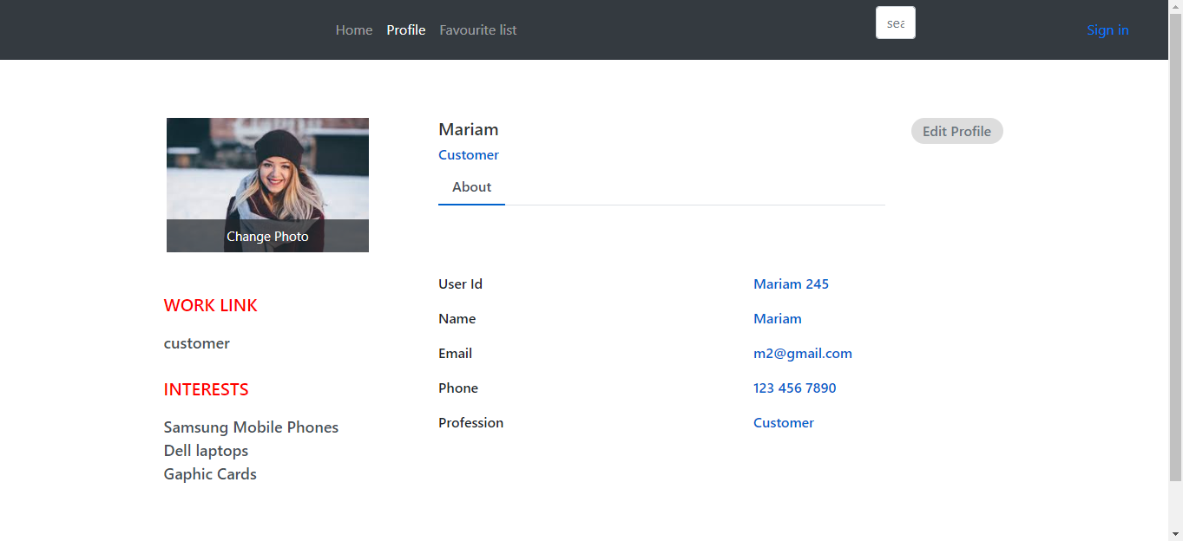

Favorite list

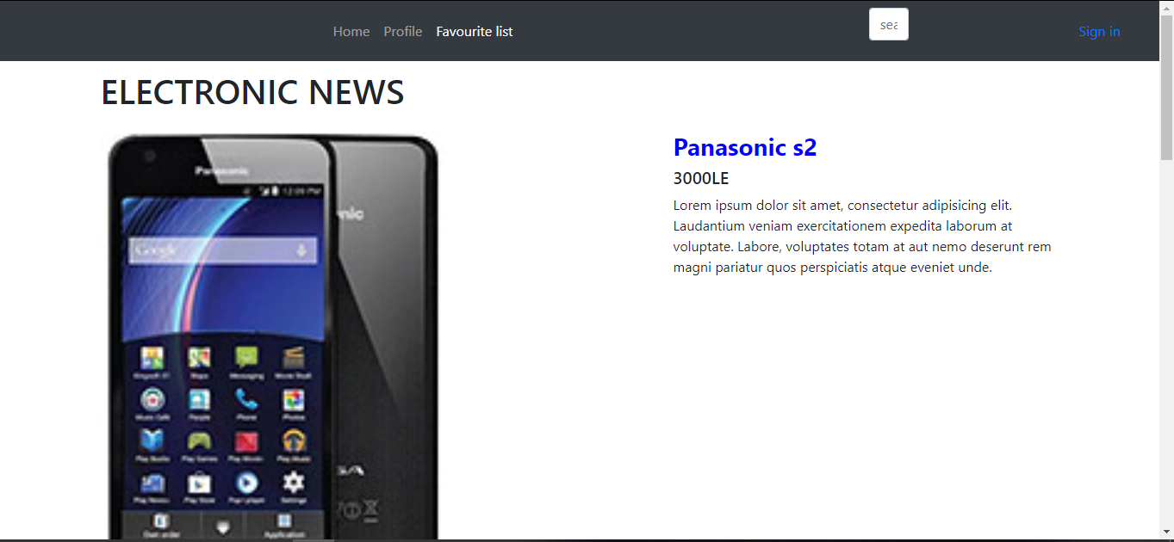

### Home

